Appendix 5: Warehouse Scope of Service

Inbound Transport

Service Specifications
- Arranging pick-up schedule with airport, after receiving the released documents from Porsche China (PCN) Customs clearance agency
- Loading of goods at Airport, Seaport or other place designated by PCN
- Arrange CIQ (China Entry-Exit Inspection and Quarantine) inspection for sea freight if applicable
- Reporting of goods or goods package damage or discrepancy
- Payment of terminal handling charges as per outlay to airport or seaport and claim to Porsche China with original invoices.
- Deliver goods to PCN regional distribution warehouse or other place designated by PCN in Dongguan City, China
- Unloading of goods at PCN warehouse
- Providing daily lead-time tracking report and monthly KPI report
- Duplicated pick-up resource arrangement need to be approved by PCN. If pick-up truck is arranged but not works due to PCN reason, the empty pick-up truck fee shall be charged as 50% of the normal one.

Remarks
- Close and suitable truck must be utilized in pick up and transport for Airfreight shipments
- DG licensed truck must be utilized in pick-up DG goods.

Warehousing

Basic Operation Principles
    - Inbound

2.2.3 Basic Operation Scope & Documentation
No. | Process | Description
1. | Warehouse operation | • Unloading (Inbound handover sheet)  • Sorting (PAG koli label)  • Put away (Part label)  • Chinese labelling  • Downloading dealer orders from system to RF gun as per Stock and VOR standard operation timeline  • Pick (Picking label)  • Pack (Koli label)
2. | Shipping | • Shipment handover  • PGI
3. | Inventory management | • DG goods management  • Replenishment Management  • Inventory checks & Annual inventory count  • Cycle count  • Shelf life parts management  • Consumables materials management  • Warehouse 6S management  • Others
4. | Parts return | • Create deliveries for return parts in system (Dealer return request)  • Checking & take photos if applicable (return label)  • Put away
5. | Reporting | • Warehouse KPI Report  • Warehouse inventory adjustment Report  • Parts Discrepancy Report (Inbound shortage , outbound overage)  • Inbound Damage Report  • Daily Inbound & outbound tracking Report  • Inventory report (cycle count, shelf life inspection, etc)

Service Specifications
    - Warehouse Logistics – Goods Receipt
- Goods document receipt in warehouse customer service
- Shipment package quantity verification, unloading of goods (SOP is as below)
- Goods on-dock;
- Shipment sorting (SOP is as below), pre-packing for some special parts, checking parts according to full inspection list and stick on Full INSPECTION label. The full inspection rate is approximate 10%.
- Parts put away include normal & special parts and cross docking parts (SOP is as below).
- Reporting of any discrepancy of inbound shipment, include inbound shortage, overage, and damage and Improper Package of transport and storage (refer to above sorting process)
- SP is required to handle all damage goods and discrepancy in quantity or parts properly. For any damages, SP needs to take pictures as record and send <Damage Report> to PCN. Damage goods need also be stored separately from normal goods for further inspection and instructions from PCN. For discrepancy in quantity, SP needs to record the quantity differences and send <Discrepancy Report> to PCN for further instruction. For discrepancy in parts, SP needs to take pictures as record and send <Discrepancy Report> to PCN for further instruction.

    - Warehouse Logistics – Stock Maintenance
- The goods are placed in specific packaging type, planned by Porsche AG. In general, packed goods store in the rack system
- Replenishment needs to be maintained regularly. SP shall replenish parts from the storage location to picking location according to the replenishment plan made by inventory management team who will run inventory list from the system and calculate the base line.
- Hazardous substances are stored in accordance with the relevant statutory requirements
- All parts stock placement should follow up warehouse 6S management level.
- Prompt posting of stock maintenance (SOP is as below)

2.3.3 Warehouse Logistics - Picking and Packing
- Download dealer orders from system as per Stock and VOR standard operation timeline
- Select separated picking area and allocate picker according to different picking logic
- Confirm TO and print picking label
- Picking goods by dealer/ batch/ material
- Consolidate parts per dealer to specified packing area.
- Check parts outbound condition and close koli to complete parts packing process, parts packing should comply with safe, economic, effective package principle.
- Input package weight, volume, dealer information of each package.
- Move packages to specific outbound area
SOP is as below flow chart:
- Creation of packing list through SAP system.
- Parts and documents handover to transport service provider.
- PGI process, warehouse outbound customer service should complete post goods issue and record in daily outbound report.
SOP is as below flow chart:

2.3.4 Warehouse Logistics – Special Topics
- Discrepancy documentation (parts shortage, parts overage, parts damage, package improvement)
- Cycle count and Annual Inventory Count: SP is required to provide 100% inventory count on a yearly basis, normally at mid/end of each year. In additional, SP shall perform weekly cycle count with following principal – all parts should be count two times per year, to correct any inventory or location mistakes. One day before annual count, all discrepancies movement will be reconciled and SP shall compensate PCN for any loss based on dealer cost prices. Stock count results will be measured according to the KPI requirements and subjected to Bonus/Malus system. SP will be accountable for inventory discrepancy found during the annual count and will need to compensate PCN accordingly based on the dealer cost price. The compensation charge will be deducted in monthly billing. (SOP is as below)
- Shelf life parts management (SOP is as below)
- Warehouse housekeeping: SP has to adopt and follow “6S” management in warehouse, which is one of important KPI and counted into Bonus/Malus measurement. SP is required to provide cleaning (at least 1 x shift) for both warehouse and social area. SP shall make sure that the warehouse is in tip-top condition using the necessary cleaning equipment required. Daily cleaning activity needs to be recorded. PCN will conduct regular 6S audit in warehouse.
- Parts return (SOP is as below)
- Scrapping: Parts scrapping need to be agreed and supervised by PCN. Usually, it will be conducted by the designated scrapping company of PCN. But should the part scrapping by done by SP, SP needs report the scrapping in details (with photos and scrapping certificate). DG need to be disposed properly according to local regulations. SP need to picking-and-packing goods accurately and handing over to transportation SP for truck loading as normal parts outbound process. For non-warranty core return parts, SP should check parts status and send related picture information to PCN.
- Other Special requirements from PCN (Check inventory stock, take parts photos, make or stick labels, change manual of PDS…) SP shall follow up PCN requests in daily warehouse management.
- SP is required to handle and label DG in accordance with the applicable international and local laws and regulations (e.g. licenses, certifications, audits, trained and certified staff, and etc). PCN request SP to provide a solution for DG in accordance with relevant laws, ordinances and regulations on the storage and handling of DG and environmentally harmful substances. The currently valid version of these rules and laws at the time concerned shall prevail in each case. PCN will not be responsible for any circumstances that may be caused by SP by not complying with the international and local regulations.
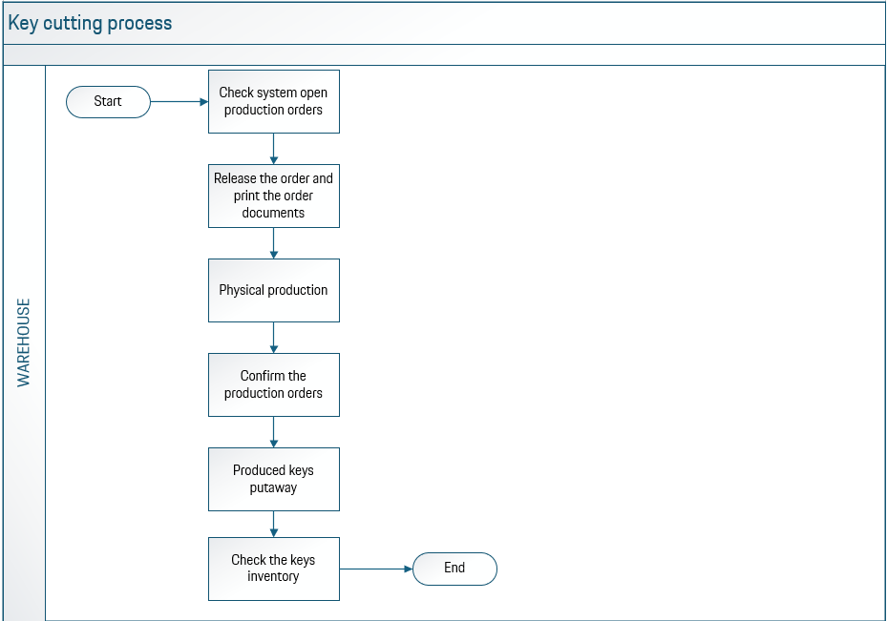
- Key cutting operation(process as below)

The key cutting machine are setup by Porsche properly, all the procedures are automatic. Supplier needs to:
- follow the procedures/manual strictly
- report to PCN immediately in case of any error happened
- keep the key cutting machine clean and tidy
- no brutal operations to the machine
- monitor the key components safety stock closely and report to PCN on monthly basis
If there are any keys production mistake made by supplier, supplier shall compensate PCN the loss based on the produced keys dealer price. Also PCN reverse the right to charge supplier about the reputation loss or other economic loss which is caused by the supplier key cutting operation mistake

- Customs Inspection operation
Customs inspection operation is aim to block the incoming goods in specific area based on the customs broker notice, and support customs officers to complete the physical inspections in warehouse, release the stock until the final notice
In case of any supplier mistake, e.g. items not blocked and sold out, supplier shall inform PCN immediately, and cooperate with PCN & customs broker to solve the issue or minimize the loss. In such case, supplier shall bear all the costs of the solution related, reputation/economic loss to PCN, and penalty- if any. Also the mistake shall be counted to KPI failure of “Responsiveness”
The SOP is as below
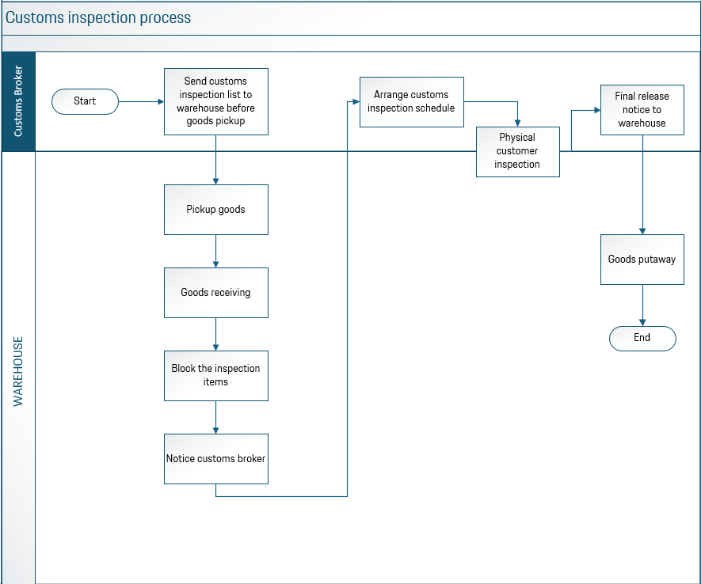

- Customer care service
Supplier shall be responsible to provide qualified and experienced persons to provide PCN following services additionally. currently we have 3 persons to handle the volume, but it can be adapted based on the future volume change
The following content represents the core work requirements of this service, and specific work content will be adjusted based on actual circumstances.
- Dealer support topics
- ET/AT&TEQ parts outbound claim issue (shortage, overage, mis-picking, damage, wrong contents, quality issue,transportation issue, abnormal issue communication with dealer, warehouse, logistics, PAG, TCC)
- PDS parts claim & after sales warranty (damage, quality issue, abnormal issue communication with dealer, PLH sales &logistics team, Arvato, PLH customer service team)
- ASR return (ASR parts disqualified & overstock)
- Core account balance & Overdue U-parts tracking
- Workshop Campaign parts claims (over 5 years)
- Internal claims (Sales label ordering, PEC/ Charge team claims)
- Parts claims summery & Claims case random check
- Logistics topics
- Normal logistic claim issue (shortage, overage, mis-picking, damage)
- Return parts abnormal issue (communication with dealer support, warehouse, transport company)
- Dongguan warehouse claim issue
- Nonflyable parts management
- Inbound Overage posting
- Ecommerce related support
- PDS&TEQ topics
- PPN content publishing and communication preparation admin
- PDS shipment monitor update
- PDS availability related communication (internal & external)
- Reporting
- PLH backorder status check and monitoring

- Engrave steel seal for engines
Rarely we will get requests from dealers to engrave steel seal for engines, the supplier will need to follow the guideline and use PCN provided machine to finish such operation

2.3.5 Emergency Response Plan
SP undertakes to maintain an organization of resources and a work force necessary to guarantee the continuity and timeliness of the warehouse operation service. Only temporary interruptions or stoppages due to accidental causes or causes of force majeure will be permitted, with the obligation to restore complete service operation in as short a time as possible, and in any case no later than 24 hours.

Each event that causes total or partial interruption of the service shall be immediately documented and notified in writing to PCN within one hour.

SP shall describe their Emergency Response Plan including an escalation plan, on how they handle emergency situation such as equipment problem, facility problem, staff management, strike, traffic accident, and etc, to avoid any business disruption. SP shall comply with the Emergency Response Plan, once it is approved by PCN.

2.3.8 Matrix of Responsibilities
Below matrix will give a clear picture on responsibility of each party.
Responsibilities | SP | PCN
Intermediary Transportation
Vehicle route planning | 
Vehicle checking | 
Shipment handover from customs broker to transporter | 
Shipments packages checking | 
Abnormal handling | 
Emergency handling | 
Return of empty containers to Shanghai seaport | 
Facility
Cleaning of building | 
Layout design of office and warehouse | 
Security of building | 
Floor marking | 
Storage Equipment
Storage equipment investment | 
Storage equipment installation | 
Storage equipment repair and maintenance | 
Operations
Inventory management |  | 
Dealer order processing | 
Delivery note documents | 
Delivery note printing | 
Order controlling and tracking | 
Account Management | 
Customer Service (7x24hrs hotline support) | 
Operation team structure and management | 
Warehouse operation management | 
Inbound unloading and checking | 
Put away and storage | 
Inventory maintenance | 
Picking, packing and preparing for dispatch | 
Outbound checking | 
Chinese labelling | 
Damage parts handling | 
Dangerous goods handling | 
Inventory count | 
Consumable goods handling, include purchasing | 
Reporting | 
Detailed SOP | 
Waste disposal | 
Issuing Fapiao | 
Warehouse equipment and device maintenance | 
On-site supervision and management | 
Implementation |  | 
Warehouse Relocation
ramp-up plan | 
Inventory move and operation |  | 
Other Investments
System (software) |  |   (PCN EWM/SAP)
IT- Equipment cabling, internet access, leased line, scanner wireless router for SIT system and scanner. |  | 
IT- Equipment – PC, label printer and laser printer |    | 
Office decoration | 
Office furniture & equipment, phone, internet access | 
Cabling in warehouse and office areas | 
Warehouse devices and equipment (e.g. material handling equipment) | 
Packing equipment (e.g. staplers, shrink wrap machine, weighing machine and etc) | 
Packaging boxes or containers | 
Consumables for packing | 
Security and Alarm system | 
Labels | 
Insurance | 

